1. Squares of a Sorted Array:
#CODE:
class Solution {
public int[] sortedSquares(int[] nums) {

int n = nums.length;
int[] result = new int[n];

int left = 0;
int right = n - 1;

for (int i = n - 1; i >= 0; i--) {

if (Math.abs(nums[left]) > Math.abs(nums[right])) {
result[i] = nums[left] * nums[left];
left++;
} else {
result[i] = nums[right] * nums[right];
right--;
}
}

return result;
}
}

OUTPUT:
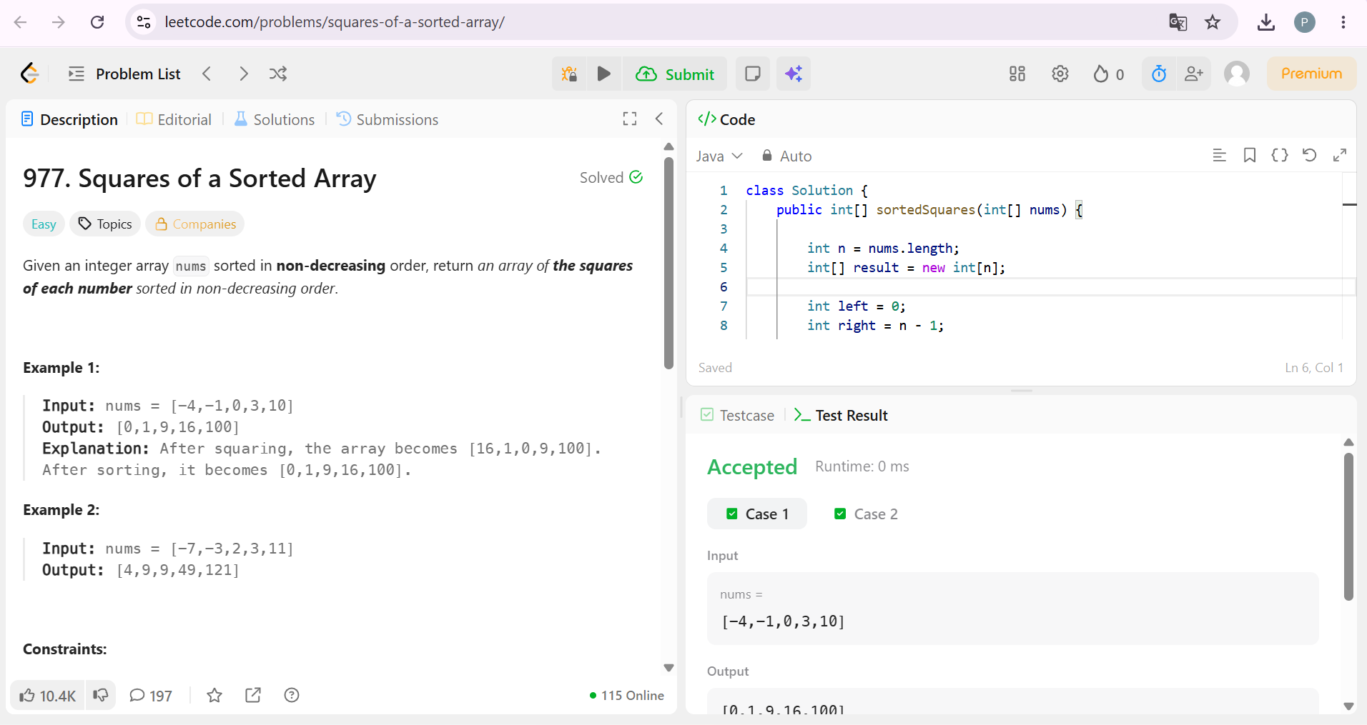

2. Find Pivot Index:
#CODE:
class Solution {
public int pivotIndex(int[] nums) {

int totalSum = 0;

// Find total sum
for (int num : nums) {
totalSum += num;
}

int leftSum = 0;

// Find pivot index
for (int i = 0; i < nums.length; i++) {

int rightSum = totalSum - leftSum - nums[i];

if (leftSum == rightSum) {
return i;
}

leftSum += nums[i];
}

return -1;
}
}
OUTPUT:
